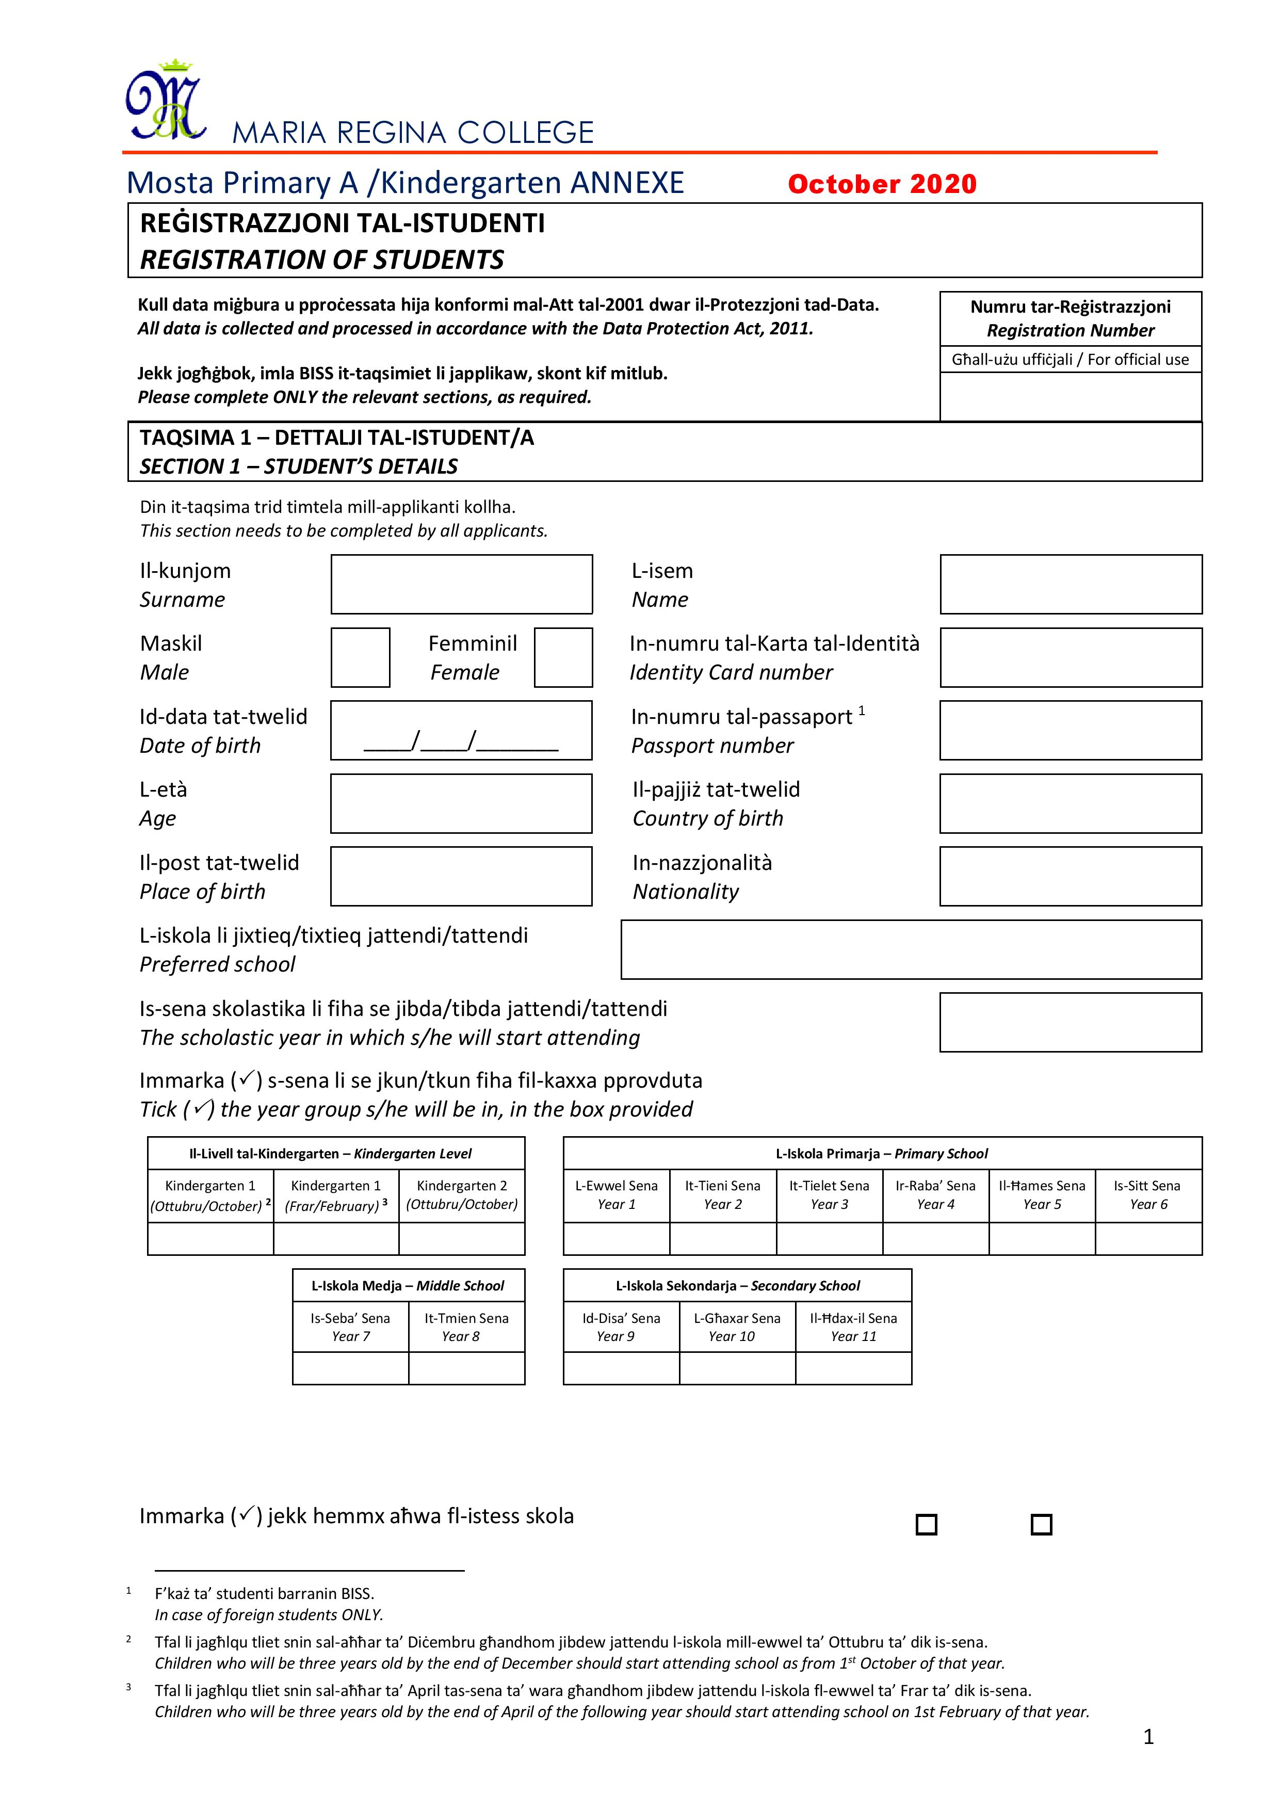

REĠISTRAZZJONI TAL-ISTUDENTI
REGISTRATION OF STUDENTS
Kull data miġbura u pproċessata hija konformi mal-Att tal-2001 dwar il-Protezzjoni tad-Data.
All data is collected and processed in accordance with the Data Protection Act, 2011.
Jekk jogħġbok, imla BISS it-taqsimiet li japplikaw, skont kif mitlub.
Please complete ONLY the relevant sections, as required.
TAQSIMA 1 – DETTALJI TAL-ISTUDENT/A
SECTION 1 – STUDENT’S DETAILS
Din it-taqsima trid timtela mill-applikanti kollha.
This section needs to be completed by all applicants.
Il-kunjom  Surname |  |  |  |  |  |  | L-isem  Name
Maskil  Male |  |  | Femminil  Female |  |  |  | In-numru tal-Karta tal-Identità  Identity Card number
Id-data tat-twelid  Date of birth |  | ____/____/______ |  |  |  |  | In-numru tal-passaport  Passport number
L-età  Age |  |  |  |  |  |  | Il-pajjiż tat-twelid  Country of birth
Il-post tat-twelid  Place of birth |  |  |  |  |  |  | In-nazzjonalità  Nationality
L-iskola li jixtieq/tixtieq jattendi/tattendi
Preferred school
Is-sena skolastika li fiha se jibda/tibda jattendi/tattendi
The scholastic year in which s/he will start attending
Immarka () s-sena li se jkun/tkun fiha fil-kaxxa pprovduta
Tick () the year group s/he will be in, in the box provided
Il-Livell tal-Kindergarten – Kindergarten Level |  |  |  |  |  | L-Iskola Primarja – Primary School
Kindergarten 1  (Ottubru/October) | Kindergarten 1 (Frar/February) |  |  | Kindergarten 2  (Ottubru/October) |  | L-Ewwel Sena  Year 1 |  | It-Tieni Sena  Year 2 |  | It-Tielet Sena  Year 3 |  | Ir-Raba’ Sena  Year 4 |  |  | Il-Ħames Sena  Year 5 |  |  | Is-Sitt Sena  Year 6
 | L-Iskola Medja – Middle School |  |  |  |  | L-Iskola Sekondarja – Secondary School
 | Is-Seba’ Sena  Year 7 |  |  | It-Tmien Sena  Year 8 |  | Id-Disa’ Sena  Year 9 |  |  | Id-Disa’ Sena  Year 9 |  | Id-Disa’ Sena  Year 9

Immarka () jekk hemmx aħwa fl-istess skola
Tick () if there are siblings in the same school
 |  |  | Iva (Yes) | Le (No)
Jekk iva, niżżel isem ħuh/a jew oħtu/oħtha u l-klassi li qiegħed/qiegħda fiha  If yes, write down his/her brother’s or sister’s name and the class in which s/he is | L-isem  Name
Il-klassi
Class

Immarka () jekk xi wieħed mill-ġenituri/kustodju legali jaħdem fl-istess skola/Kulleġġ
Tick () if one of the parents/legal guardian works in the same school/College
 | Iva (Yes) | Le (No)

Jekk iva, niżżel ismu/isimha u l-grad tiegħu/tagħha  If yes, write down his/her name and grade |  | L-isem  Name
Il-grad
Grade
L-indirizz postali tal-istudent/a
Postal address of student
L-indirizz postali tal-istudent/a  Postal address of student |  |  |  |  | Il-kodiċi postali  Postcode
It-telefown tad-dar
Home telephone number

TAQSIMA 2 – DETTALJI ADDIZZJONALI TAL-ISTUDENT/A F’KAŻ TA’ TRASFERIMENT MINN SKOLA OĦRA
SECTION 2 – STUDENT’S ADDITIONAL DETAILS IN CASE OF A TRANSFER FROM ANOTHER SCHOOL

Din it-taqsima għandha timtela BISS mill-applikanti li qed jitolbu li t-tfal tagħhom jiġu ttrasferiti minn xi skola oħra.
This section needs to be completed ONLY by applicants who are requesting that their children be transferred from another school.
L-aħħar skola li attenda/attendiet
Last school attended
Is-sena li kien/kienet fiha
The year s/he was in
Il-lingwa li studja/t jew li se jibda/tibda jistudja/tistudja mis-Seba’ Sena (jekk applikabbli)
The language which s/he studied or will be studying as from Year 7 (if applicable)
Is-suġġetti li studja/t jew li se jibda/tibda jistudja/tistudja mid-Disa’ Sena (jekk applikabbli)
The subject/s which s/he studied or will be studying as from Year 9 (if applicable)

TAQSIMA 3 – DETTALJI ADDIZZJONALI TAL-ISTUDENT/A BI BŻONNIJIET SPEĊJALI
SECTION 3 – STUDENT WITH SPECIAL NEEDS’ ADDITIONAL DETAILS

Din it-taqsima għandha timtela BISS mill-applikanti li t-tfal tagħhom għandhom xi bżonnijiet speċjali.
This section needs to be completed ONLY by applicants whose children require special needs.
In-numru maħruġ mill-Bord dwar il-każ speċjali (jekk applikabbli)
Statementing Board number (if applicable)

Immarka () jekk l-istudent/a għandux/għandhiex diġà LSE
Mark () in the appropriate box if the student has already been assigned an LSE
 | Iva (Yes) | Le (No)

Immarka () t-tip ta’ għajnuna li qiegħed/qiegħda tirċievi (jekk applikabbli)
Mark () the type of statement (if applicable)
- Sapport fuq bażi individwali, matul il-ħin kollu tal-iskola
Full-time support, on a one-to-one basis
- Sapport mogħti matul il-ħin kollu tal-iskola, iżda mhux fuq bażi individwali
Full-time support
- Sapport offrut lil aktar minn student wieħed fl-istess klassi
Shared in the same class
- Sapport offrut lil aktar minn student wieħed, mhux neċessarjament fl-istess klassi
Shared support
- Għajnuna mogħtija mill-għalliem tal-klassi, b’kollaborazzjoni mal-LSE, jekk ikun hemm is-servizz tal-LSE fil-klassi
Benefits

Immarka () jekk l-istudent/a għandux/għandhiex trasport speċjali
Mark () in the appropriate box if the student has special transport
 | Iva (Yes) | Le (No)

TAQSIMA 4 – DETTALJI ADDIZZJONALI DWAR STUDENTI BARRANIN
SECTION 4 – FOREIGN STUDENTS’ ADDITIONAL DETAILS

Din it-taqsima għandha timtela BISS f’każ ta’ studenti barranin.
This section needs to be completed ONLY in the case of foreign students.

Immarka () biex tindika jekk hux obbligat li jsir ħlas għas-servizz edukattiv tal-istudent/a matul is-sena skolastika li se jkun/tkun qed jattendi/tattendi
Mark () in the appropriate box to indicate whether it is obligatory to pay for the student’s educational service for the year in which s/he will be attending
 | Iva (Yes) | Le (No)

TAQSIMA 5 – DETTALJI TAL-ĠENITURI JEW KUSTODJI LEGALI
SECTION 5 – DETAILS OF PARENTS OR LEGAL GUARDIANS

Din it-taqsima trid timtela mill-applikanti kollha.
This section needs to be completed by all applicants.

Isem u kunjom il-missier/kustodju legali  Father’s/legal guardian’s name & surname |  | Isem u kunjom l-omm/kustodju legali  Mother’s/legal guardian’s name & surname

In-numru tal-Karta tal-Identità  Identity Card number |  |  | In-numru tal-Karta tal-Identità  Identity Card number

In-numru tal-passaport  Passport number |  |  | In-numru tal-passaport  Passport number

Il-pajjiż tat-twelid  Country of birth |  |  | Il-pajjiż tat-twelid  Country of birth
In-nazzjonalità  Nationality |  |  | In-nazzjonalità  Nationality

In-numru tat-telefown  Telephone number |  |  | In-numru tat-telefown  Telephone number

In-numru tal-mowbajl  Mobile phone number |  |  | In-numru tal-mowbajl  Mobile phone number

L-indirizz postali tal-missier/kustodju legali  Postal address of father/legal guardian |  |  |  | L-indirizz postali tal-missier/kustodju legali  Postal address of father/legal guardian
 | Il-kodiċi postali  Postcode |  |  |  | Il-kodiċi postali  Postcode

L-indirizz elettroniku  e-mail address |  |  | L-indirizz elettroniku  e-mail address

TAQSIMA 6 – RAĠUNIJIET MOGĦTIJA GĦAR-REĠISTRAZZJONI TAL-ISTUDENT/A FL-ISKOLA MAGĦŻULA
SECTION 6 – REASONS GIVEN FOR THE STUDENT’S REGISTRATION IN THE CHOSEN SCHOOL
Din it-taqsima għandha timtela BISS mill-ġenituri/kustodji legali li MA JOQOGĦDUX fl-istess lokalità tal-iskola li fiha jixtiequ jirreġistraw lit-tifel/tifla/tfal tagħhom.
This section needs to be completed ONLY by parents or legal guardians who DO NOT RESIDE in the same locality of the school in which they would like to register their child/ren.

TAQSIMA 7 – DIKJARAZZJONI MILL-ĠENITURI JEW KUSTODJI LEGALI
SECTION 7 – DECLARATION FROM PARENTS OR LEGAL GUARDIANS

Din it-taqsima għandha timtela mill-ġenituri (l-omm u l-missier) jew il-kustodji legali.
This section needs to be completed by both parents or legal guardians.

Aħna, il-ġenituri/kustodji legali ta’ (niżżel l-isem u l-kunjom sħiħ tat-tifel/tifla)
solennement niddikjaraw illi, safejn nafu aħna, l-informazzjoni kollha li niżżilna f’din il-formola hija korretta.
We, the parents/legal guardians of (full name and surname of the child)
solemnly declare that, to the best of our knowledge and belief, the information in this application is correct.
Il-firma tal-missier/kustodju legali
Father’s/legal guardian’s signature

Il-firma tal-omm/kustodju legali
Mother’s/legal guardian’s signature

Id-data  Date | ______/______/________

TAQSIMA 8 – DOKUMENTI MEĦTIEĠA
SECTION 8 – DOCUMENTS REQUIRED

1. |  | Ċertifikat tat-twelid tat-tifel/tifla (f’każ ta’ studenti barranin BISS).  Child’s birth certificate (in case of foreign students ONLY).
2. |  | F’każ ta’ ġenituri separati/divorzjati, ikunu meħtieġa d-dokumenti uffiċjali dwar il-kustodja tat-tifel/tifla (jekk applikabbli).  In case of separated/divorced parents, the official documents of the child’s custody (if applicable), are required.
3. |  | F’każ li wieħed mill-ġenituri/kustodji legali jirrifjuta jew ma jkunx jista’ jiffirma din il-formola, għal kwalunkwe raġuni, kif mitlub f’Taqsima 7, ikun meħtieġ li jsir rikors fil-Qrati ta’ Malta biex it-talba għar-reġistrazzjoni tat-tifel/tifla fl-iskola magħżula tkun tista’ tiġi pproċessata mingħajr il-kunsens tal-parti l-oħra. It-talba għar-reġistrazzjoni tat-tifel/tifla tkun tista’ tiġi pproċessata BISS meta kopja tad-dokument uffiċjali, maħruġ mill-Qorti, ikun ippreżentat ma’ din il-formola.  If one of the parents/legal guardians refuses or is not able to sign this form, for whatever reason, as required in Section 7, an application needs to be filed in the law courts of Malta so that the request for the registration of the child in the chosen school could be processed without the other party’s consent. The request for the registration of the child could ONLY be processed when a copy of the official document, issued by the court, is presented with this form.
4. |  | Kopja bil-kulur tal-Karta tal-Identità tal-ġenituri/kustodji legali (miż-żewġ naħat) JEW kopja tal-passaporti tagħhom (tradotti għall-Ingliż b’mod uffiċjali, f’każ ta’ ġenituri barranin). Il-kopja tal-Karta tal-Identità jew tal-passaporti għandha tkun iffirmata mill-applikanti. L-applikanti għandhom jippreżentaw ukoll id-dokumenti oriġinali meta jirreġistraw lit-tfal tagħhom.  A photocopy in colour of the parents’/legal guardian’s Identity Card (back & front) OR a copy of their passports (translated officially into English, in case of foreign parents). The photocopies of the Identity Card or passports should be signed by the applicants. Applicants should also present the original documents when they register their children.
5. |  | F’każ ta’ ġenituri barranin jew ġenituri li sejrin joqogħdu fl-istess lokalità fejn tinsab l-iskola li fiha jixtiequ jirreġistraw lit-tfal tagħhom, ikun meħtieġ kopja tal-kuntratt tal-kirja jew konvenju.  In case of foreign parents or parents who will be residing in the same locality as the school they wish to register their children in, a copy of the leasing agreement or promise of sale is required.
6. |  | Jekk issir talba mill-ġenituri/kustodji legali biex it-tifel/tifla tiġi reġistrata ġo skola li mhix fil-lokalità li jkunu joqogħdu fiha huma u r-raġuni li tingħata (f’Taqsima 6) tkun li t-tnejn jaħdmu, u għaldaqstant ma jkunux jistgħu jwasslu jew jiġbru lit-tfal tagħhom lejn u mill-iskola, ikun meħtieġ li tinħareġ ittra uffiċjali mill-ETC jew minn min jimpjega lill-ġenituri/kustodji legali, li tiċċertifika li t-tnejn tabilħaqq jaħdmu. Importanti li l-ħinijiet tax-xogħol ikunu indikati.  If a request is made by the parents/legal guardians to register their children in a school which is not in the locality in which they reside and the reason given (in Section 6) is related to the fact that both parents work, and therefore could not bring and pick up their children to and from school, an official letter from ETC or the employers of the parents/legal guardians will be needed in order to certify that they both work. It is important that the hours of work are indicated.
7. |  | Ittra ta’ kunsens minn min se jkun qiegħed iwassal u/jew jiġbor lit-tifel/tifla lejn u mill-iskola, minflok il-ġenituri/kustodji legali (jekk applikabbli).  Letter of consent, written by a third party, who will assume the responsibility of bringing and/or picking the child to and from school instead of the parents/legal guardians (if applicable).
8. |  | Ittra ta’ kunsens mill-ġenituri/kustodji legali fejn jawtorizzaw lil ħaddieħor biex iwassal u/jew jiġbor lit-tifel/tifla tagħhom lejn u mill-iskola (jekk applikabbli).  Letter of consent by parents/legal guardians in which they authorize a third party to assume the responsibility of bringing and/or picking the child to and from school (if applicable).
9. |  | Kopja bil-kulur tal-Karta tal-Identità tal-persuna awtorizzata, kif imsemmija f’Punt 7, biex twassal u/jew tiġbor lit-tifel/tifla lejn u mill-iskola (miż-żewġ naħat) (jekk applikabbli). Il-kopja tal-Karta tal-Identità għandha tkun iffirmata mill-persuna awtorizzata. Il-Karta tal-Identità oriġinali għandha tiġi ppreżentata wkoll.  A photocopy in colour of the Identity Card of the person who is authorized, as mentioned in Point 7, to assume the responsibility of bringing and/or picking the child to and from school (back & front) (if applicable). The photocopy of the Identity Card should be signed by the authorized person. The original Identity Card should also be presented.
10. |  | Ċertifikat tal-mewt jekk xi wieħed mill-ġenituri/kustodju legali jkun nieqes (f’każ ta’ studenti barranin BISS).  Death certificate if one of the parents/legal guardians is deceased (in case of foreign students ONLY).
11. |  | Dokumenti oħra li jistgħu jsaħħu t-talba tal-applikanti.  Any other documents which could substantiate further the applicants’ request.
12. |  | Dokumenti oħra li jistgħu jintalbu mill-Kulleġġ jew l-Iskola.  Any other documents which could be requested by the College/school.

NOTI IMPORTANTI:
- Studenti li ma joqogħdux f’xi waħda mil-lokalitajiet tal-Kulleġġ, ma jistgħux jingħataw is-servizz tat-trasport.
Students who reside outside the College localities cannot be provided with transport arrangements.
- F’każ ta’ ġenituri/kustodji legali li MA JOQOGĦDUX fl-istess lokalità tal-iskola li fiha jixtiequ jirreġistraw lit-tfal tagħhom, din l-applikazzjoni għandha tintbagħat fl-Uffiċċju tal-Kap tan-Network tal-Kulleġġ.
In the case of parents/legal guardians who DO NOT RESIDE in the same locality of the school in which they would like to register their children, this application should be sent to the Office of the Head College Network.
- F’każ ta’ ġenituri/kustodji legali li JOQOGĦDU fl-istess lokalità li fiha jixtiequ jirreġistraw lit-tfal tagħhom, din l-applikazzjoni għandha tintbagħat lill-amministrazzjoni tal-iskola.
In the case of parents/legal guardians who RESIDE in the same locality of the school in which they would like to register their children, this application should be sent to the school’s administration.
- Il-ġenituri/kustodji legali għandhom jagħmlu appuntament mas-segretarjat tal-Kulleġġ jew l-Iskola (skont kif japplika) biex jiġu vverifikati d-dokumenti oriġinali.
Both parents/legal guardians should make an appointment with the College/school secretariat (depending on which is applicable) so that the original documentation can be verified.

- Talbiet aċċettati għal studenti minn lokalitajiet li ma jagħmlux parti mill-Kulleġġ, huma validi biss sakemm jgħaddi l-perjodu
tal-iskola Primarja. Meta dan il-perjodu jasal fi tmiemu, studenti li mhumiex mil-lokalitajiet tal-Kulleġġ jiġu awtomatikament
diretti għall-iskola Medja/Sekondarja tal-Kulleġġ fejn huma residenti. Għalhekk, kull talba li se ssir għal studenti li se jkunu
minn Year 7 ’il fuq minn lokalitajiet li ma jagħmlux parti mill-Kulleġġ, dawn iridu jsiru kompletament mill-ġdid.

Accepted requests for students of out of College catchment/locality are only valid for the period that the students are of Primary
school age. On completion of the Primary Years, out of catchment area students will be automatically directed to their residence
address catchment Middle/Secondary school. Any out of locality/catchment requests for Year 7 and beyond need to be submitted
again.

GĦALL-UŻU UFFIĊJALI / FOR OFFICIAL USE
- It-talba għar-reġistrazzjoni/trasferiment tal-istudent/a ġiet AĊĊETTATA
The request for student’s registration/transfer is ACCEPTED
- It-talba għar-reġistrazzjoni/trasferiment tal-istudent/a MHIX AĊĊETTATA
The request for student’s registration/transfer is NOT ACCEPTED

Il-Firma tal-Kap tan-Network/Kap tal-Iskola  Signature of Head College Network/Head of School |  | Id-data  Date | ___/___/______

F’każ ta’ studenti barranin BISS. In case of foreign students ONLY.
Tfal li jagħlqu tliet snin sal-aħħar ta’ Diċembru għandhom jibdew jattendu l-iskola mill-ewwel ta’ Ottubru ta’ dik is-sena. Children who will be three years old by the end of December should start attending school as from 1st October of that year.
Tfal li jagħlqu tliet snin sal-aħħar ta’ April tas-sena ta’ wara għandhom jibdew jattendu l-iskola fl-ewwel ta’ Frar ta’ dik is-sena. Children who will be three years old by the end of April of the following year should start attending school on 1st February of that year.
F’każ BISS li l-missier/kustodju legali jkun barrani. In case of a foreign father/legal guardian ONLY.
F’każ BISS li l-omm/kustodju legali tkun barranija. In case of a foreign mother/legal guardian ONLY.

